Jan NOWAK,*, Jan KOWALSKI¹
column dimensions for A4 format - standard margin of 2.5 cm on each side

1. Numerical modeling of the Liesegang precipitation patterns with linear and radial geometries
1.1. Introduction
Liesegang patterns are stripes, bands or rings formed by moving fronts of chemical reactions. Processes involved in formation of Liesegang patterns are diffusion, reaction and precipitation. Liesegang patterns occur in many reactions/processes and can be seen in all types of media, hard substances, gels, liquids or gases [1]. Outer electrolyte, of higher concentration diffuses into the medium and reaction with inner electrolyte takes place [2,3]. Under certain conditions precipitation of the reaction product then occurs leading to formation of layers of separate precipitates.
In contrast to the literature, where only 1D Liesageng patterns are studied numerically, our research has led to creating a stable computational environment allowing predicting outcomes of both 1D and 2D diffusion – precipitation chemical reactions [4–5].
1.2. Chemical and mathematical model
Liesegang patterns are based on reaction process of two diffusing substances. The effect of reaction is stationary product which precipitate periodically in time. Basic reaction could be represented as
where:
A, B – inner/outer electrolyte
P – reaction product
The general boundaries can be defined as
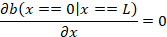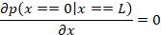
but also, important boundary named “moving boundary condition” [6], [9] which represents precipitating product at position x_{n} and at time t_{n} behaving as limit of system
where:
x_{n} – appearing band position
t_{n} – appearing band time
1.2.1. Geometry
In experiments we tested one- (1D) and two-dimensional (2D) geometry [12]. In 1D system the assumption that length is much greater than width is needed. Hence, we can interpret the diffusion process as depending only on one coordinate. The concentration of inner electrolyte was equally distributed along reaction environment and outer electrolyte was delivered at both ends. For 2D geometry to minimalize dependencies the circle geometry with same assumption of electrolytes distribution was prepared. 1D geometry was prepared with length paramter of the reaction area equal to 200 mm and 2D geometry was prepared with radius equal to 10 mm.
Table 1
Experimental models’ parameters
 | 1D model | 2D model
Inner electrolyte diffusion coefficient
Outer electrolyte diffusion coefficient
Solubility constant
Aggregation rate constant
Experiment time
1.3. Results and discussion
Using parameters described in Table 1, two models (1D and 2D) was tested and verified against Matalon-Packter law (spacing law), width law and time law. Both models are suitable to be good description of diffusion-precipitation-agglomeration system.
1.3.1. 1D model
One dimensional model was predicated using described geometry and parameters to predict creation of rings. However, problem is only described on one coordinate, rings aren’t noticeable – only where product precipitate.

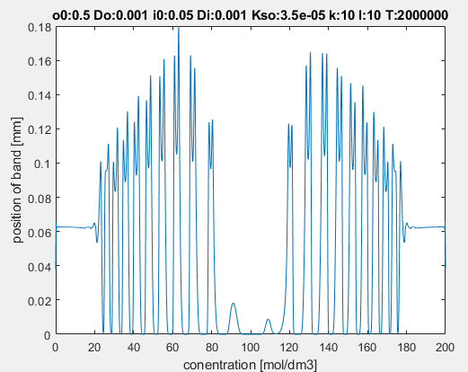
Fig. 1. Predicated bands with 1D model
Rys. 1.Wzorce przewidziane modelem 1D

Bibliography
- J. Zielińska, Sprofilowana i spersonalizowana terapia pobudzana (sterowana) danymi, Niepełnosprawność – zagadnienia, problemy, rozwiązania (2017) 23:132-148.
- T.A. Zabel, L.A. Jacobson, A.E. Pritchard, E.M. Mahone, L. Kalb, Pre-appointment online assessment of patient complexity: Towards a personalized model of neuropsychological assessment, Child Neuropsychology (2021) 27(2):232-250.
- C. Peretz, A.D. Korczyn, E. Shatil, V. Aharonson, S. Birnboim, N. Giladi, Computer-Based, Personalized Cognitive Training versus Classical Computer Games: A Randomized Double-Blind Prospective Trial of Cognitive Stimulation, Neuroepidemiology (2011) 36:91-99.

Numerical modeling of the Liesegang precipitation patterns with linear and radial geometries

MODELOWANIE NUMERYCZNE STRĄCENIOWYCH WZORCÓW LIESEGANGA DLA GEOMETRII LINIOWEJ I RADIALNEJ
Abstract
We present a computational study of reaction – diffusion – precipitation systems for two types of geometries, linear and radial. The elaborated numerical procedures allow validations of reaction – diffusion – precipitation reactions modeling assumptions and fitting model parameters to data. We used results of our study for comparing computational predictions of the obtained percipitation patterns with experimental measurements. The main contribution of our research is creating a stable computational environment allowing predicting outcomes of both 1D and 2D diffusion – precipitation chemical reactions. One area of application of the elaborated computational environment designing presonalized, controlled drug release systems, where predicting/controlling shapes and positions of reaction fronts is of high importance.

Keywords: reaction – diffusion systems, precipitation, Liesegand patterns, drug release, numerical modeling

Department of Data Science and Engineering, Faculty of Automatic Control, Silesian University of Technology, Gliwice, Poland. Corresponding author: jan.nowak@polsl.pl.

